Currency
# Source: AI Source: Provided by: [Data Path: Persons Table -> ID Column: 1, Name_En Column: Motasem Essam] -> From: [ChatGPT] on [7/17/2026]
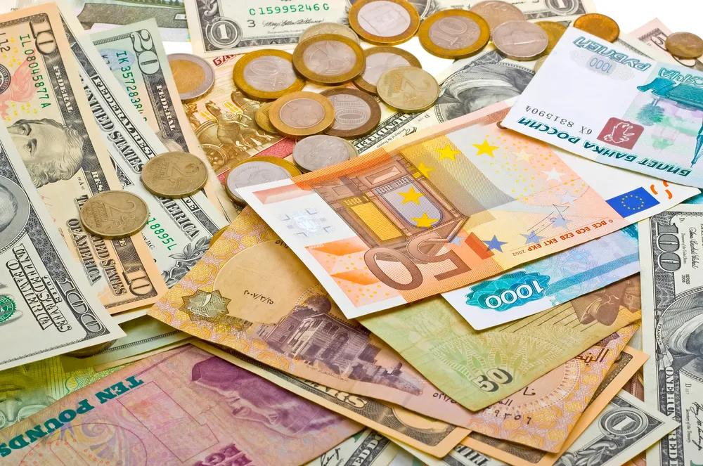
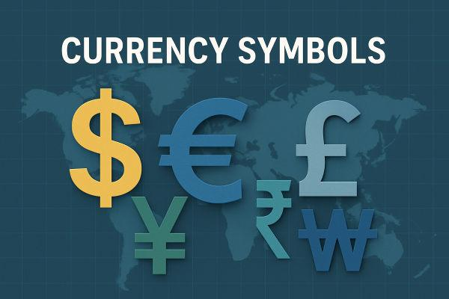
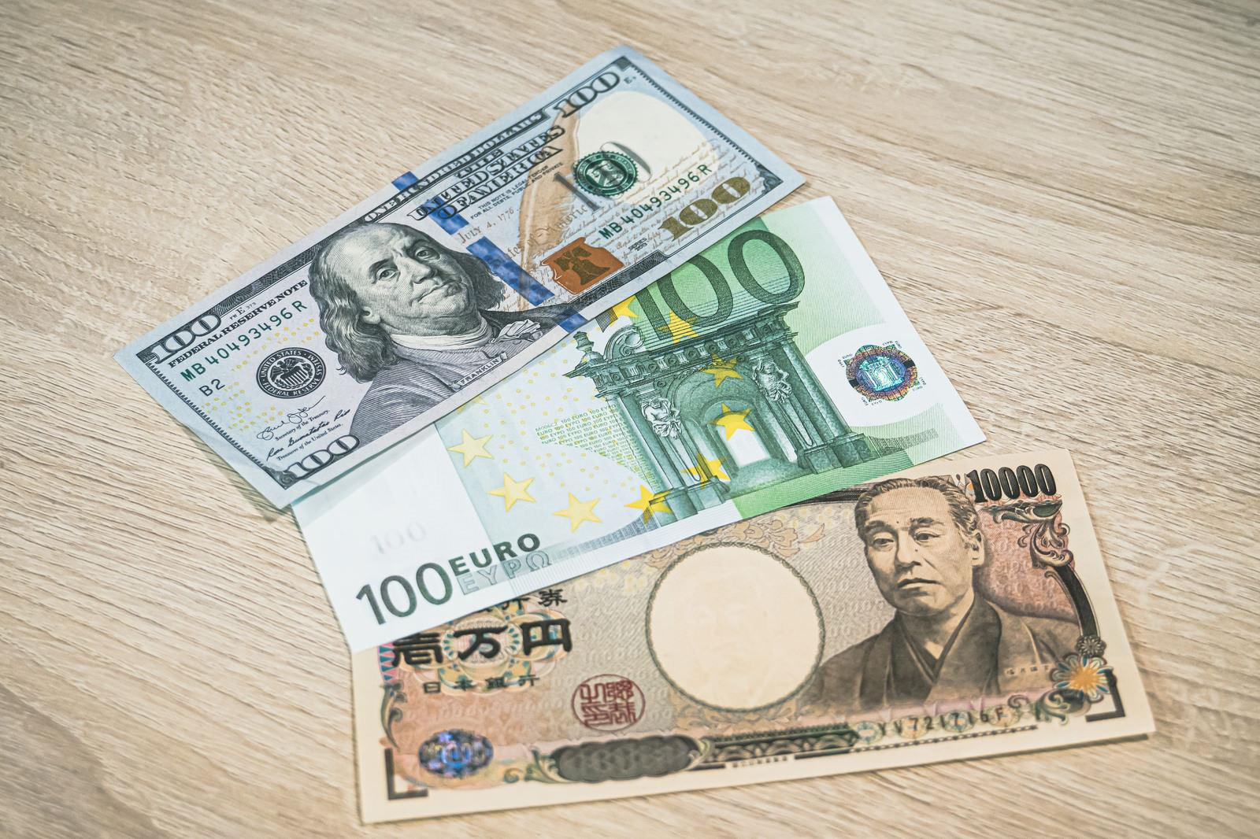


A Currency is a standardized system of money officially recognized and issued by a government or monetary authority for use as a medium of exchange within a country or group of countries. It provides the standard unit for measuring the value of goods, services, assets, and financial transactions.
Each currency has:
- A name
- A symbol
- An ISO 4217 currency code
- One or more subunits (minor units)

Definition
# Source: AI Source: Provided by: [Data Path: Persons Table -> ID Column: 1, Name_En Column: Motasem Essam] -> From: [ChatGPT] on [7/17/2026]
A Currency is an officially recognized system of money issued by a government or monetary authority and used as the standard unit for measuring and exchanging economic value.

Purpose
# Source: AI Source: Provided by: [Data Path: Persons Table -> ID Column: 1, Name_En Column: Motasem Essam] -> From: [ChatGPT] on [7/17/2026]
Currencies are used to:
- Buy goods and services.
- Measure prices.
- Store value.
- Pay debts.
- Record financial transactions.
- Facilitate domestic and international trade.

Components of a Currency
# Source: AI Source: Provided by: [Data Path: Persons Table -> ID Column: 1, Name_En Column: Motasem Essam] -> From: [ChatGPT] on [7/17/2026]
A currency usually consists of:
- Currency Name
- Currency Symbol
- Currency Code
- Major Unit
- Minor Unit
Example:
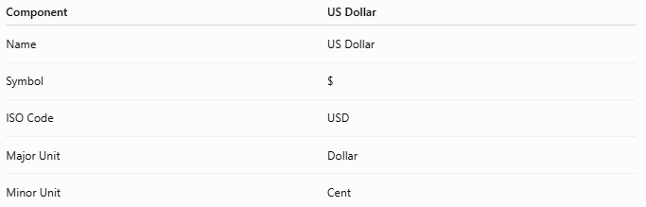
Component | US Dollar
Name | US Dollar
Symbol | $
ISO Code | USD
Major Unit | Dollar
Minor Unit | Cent

Major and Minor Units
# Source: AI Source: Provided by: [Data Path: Persons Table -> ID Column: 1, Name_En Column: Motasem Essam] -> From: [ChatGPT] on [7/17/2026]
Most currencies are divided into 100 smaller units.
Examples:
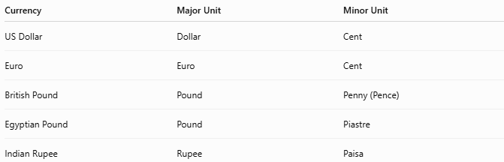
Currency | Major Unit | Minor Unit
US Dollar | Dollar | Cent
Euro | Euro | Cent
British Pound | Pound | Penny (Pence)
Egyptian Pound | Pound | Piastre
Indian Rupee | Rupee | Paisa

Currency Symbols
# Source: AI Source: Provided by: [Data Path: Persons Table -> ID Column: 1, Name_En Column: Motasem Essam] -> From: [ChatGPT] on [7/17/2026]
Examples:
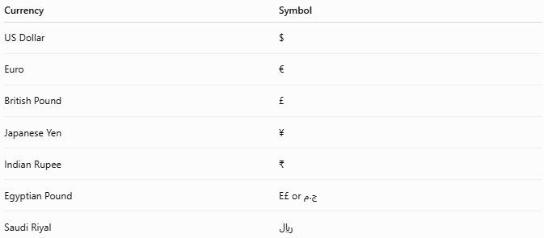
Currency | Symbol
US Dollar | $
Euro | €
British Pound | £
Japanese Yen | ¥
Indian Rupee | ₹
Egyptian Pound | E£ or ج.م
Saudi Riyal | ﷼

ISO 4217 Currency Codes
# Source: AI Source: Provided by: [Data Path: Persons Table -> ID Column: 1, Name_En Column: Motasem Essam] -> From: [ChatGPT] on [7/17/2026]
The ISO 4217 standard assigns each currency a unique three-letter code.
Examples:
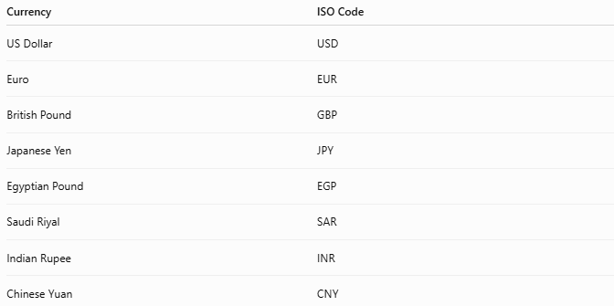
Currency | ISO Code
US Dollar | USD
Euro | EUR
British Pound | GBP
Japanese Yen | JPY
Egyptian Pound | EGP
Saudi Riyal | SAR
Indian Rupee | INR
Chinese Yuan | CNY

Types of Currency

1. Fiat Currency
# Source: AI Source: Provided by: [Data Path: Persons Table -> ID Column: 1, Name_En Column: Motasem Essam] -> From: [ChatGPT] on [7/17/2026]
Government-issued currency that has value because it is accepted by law and public trust, not because it is backed by a physical commodity.
Examples:
- US Dollar (USD)
- Euro (EUR)
- Egyptian Pound (EGP)

2. Commodity Currency
# Source: AI Source: Provided by: [Data Path: Persons Table -> ID Column: 1, Name_En Column: Motasem Essam] -> From: [ChatGPT] on [7/17/2026]
Currency whose value is directly linked to a physical commodity.
Historically:
- Gold
- Silver
Today, commodity currencies are rare.

3. Digital Currency
# Source: AI Source: Provided by: [Data Path: Persons Table -> ID Column: 1, Name_En Column: Motasem Essam] -> From: [ChatGPT] on [7/17/2026]
Currency that exists electronically.
Examples:
- Electronic bank balances
- Mobile wallet balances

4. Cryptocurrency
# Source: AI Source: Provided by: [Data Path: Persons Table -> ID Column: 1, Name_En Column: Motasem Essam] -> From: [ChatGPT] on [7/17/2026]
Digital currency secured using cryptography.
Examples:
- Bitcoin (BTC)
- Ethereum (ETH)
Unlike fiat currencies, cryptocurrencies are generally decentralized and may experience significant price fluctuations.

Issuing Authority
# Source: AI Source: Provided by: [Data Path: Persons Table -> ID Column: 1, Name_En Column: Motasem Essam] -> From: [ChatGPT] on [7/17/2026]
Currencies are usually issued by a central bank or national monetary authority.
Examples:
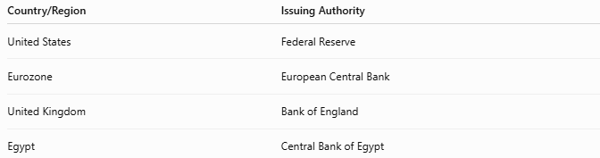
Country/Region | Issuing Authority
United States | Federal Reserve
Eurozone | European Central Bank
United Kingdom | Bank of England
Egypt | Central Bank of Egypt

Currency Exchange
# Source: AI Source: Provided by: [Data Path: Persons Table -> ID Column: 1, Name_En Column: Motasem Essam] -> From: [ChatGPT] on [7/17/2026]
Currencies can be exchanged for one another using exchange rates.
Example:
- 1 USD = X EGP
- 1 EUR = Y USD
Exchange rates change because of:
- Supply and demand
- Inflation
- Interest rates
- Economic conditions
- Government policies

Applications
# Source: AI Source: Provided by: [Data Path: Persons Table -> ID Column: 1, Name_En Column: Motasem Essam] -> From: [ChatGPT] on [7/17/2026]
Currencies are used in:
- Banking
- International trade
- Business
- Government
- Accounting
- Personal finance
- Tourism

Characteristics of a Good Currency
# Source: AI Source: Provided by: [Data Path: Persons Table -> ID Column: 1, Name_En Column: Motasem Essam] -> From: [ChatGPT] on [7/17/2026]
A good currency should be:
- Durable
- Portable
- Divisible
- Uniform
- Widely accepted
- Stable in value
- Difficult to counterfeit

Advantages
Currencies:
- Simplify trade.
- Provide a standard measure of value.
- Enable savings and investment.
- Support national and international economies.

Common Mistakes
# Source: AI Source: Provided by: [Data Path: Persons Table -> ID Column: 1, Name_En Column: Motasem Essam] -> From: [ChatGPT] on [7/17/2026]
- Confusing currency with money.
  - Money is the broader concept (anything accepted as a medium of exchange).
  - Currency is the official form of money issued by a government or monetary authority.
- Assuming all currencies have equal purchasing power.
- Believing currency values never change (exchange rates fluctuate continuously).

Examples of Major World Currencies
# Source: AI Source: Provided by: [Data Path: Persons Table -> ID Column: 1, Name_En Column: Motasem Essam] -> From: [ChatGPT] on [7/17/2026]
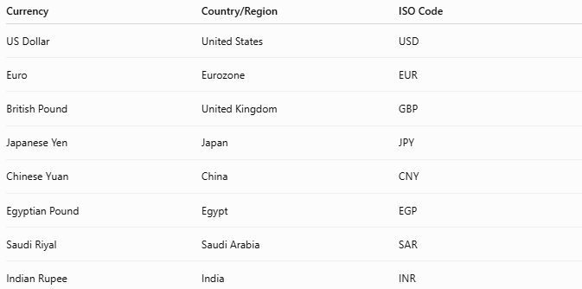
Currency | Country/Region | ISO Code
US Dollar | United States | USD
Euro | Eurozone | EUR
British Pound | United Kingdom | GBP
Japanese Yen | Japan | JPY
Chinese Yuan | China | CNY
Egyptian Pound | Egypt | EGP
Saudi Riyal | Saudi Arabia | SAR
Indian Rupee | India | INR

Key Points
# Source: AI Source: Provided by: [Data Path: Persons Table -> ID Column: 1, Name_En Column: Motasem Essam] -> From: [ChatGPT] on [7/17/2026]
- A Currency is the official system of money used in a country or region.
- Every currency has:
  - A name
  - A symbol
  - An ISO code
  - Major and minor units
- Most modern currencies are fiat currencies.
- Exchange rates determine the relative value between different currencies.
- Currencies are fundamental to trade, finance, and economic measurement.

Conclusion
# Source: AI Source: Provided by: [Data Path: Persons Table -> ID Column: 1, Name_En Column: Motasem Essam] -> From: [ChatGPT] on [7/17/2026]
A Currency is the officially recognized form of money used to measure and exchange economic value within a country or region. Issued by governments or central banks, currencies provide a standardized system for pricing goods, paying for services, recording financial transactions, and supporting domestic and international trade. Through features such as symbols, ISO currency codes, and exchange rates, currencies enable efficient economic activity and serve as one of the most important tools in modern financial systems.

